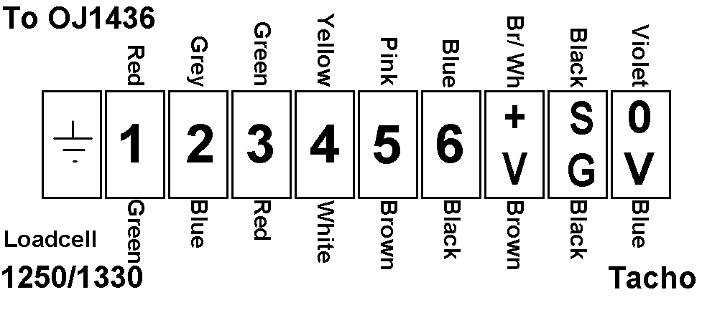
10-pin connector:
1 – Red
2 – Green
3 – Yellow
4 – Blue
5 – Brown/white
6 – Black
7 – Violet
8 – Grey
9 – Screen
10 – Pink
